How to update the BIOS of VDX-6327

- Prepare a USB thumb drive with DOS system (win98, freedos, or dos6.22)
and copy the rom file of 6327A5.rom to the USB thumb drive.
Also copy the file “ SPIFLASH.exe” to the USB thumb drive.

- Power on the board of VDX-6327 and into the DOS system and type in the commend as below
C:\>spiflash u 6327A5.rom press “enter”
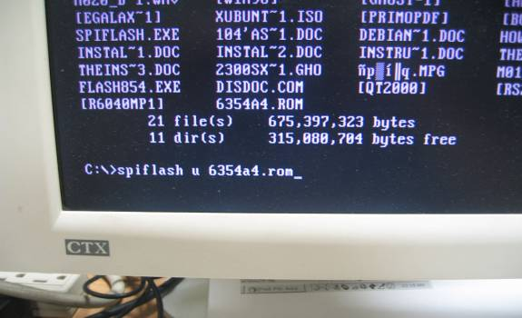

3. Waiting for the ADDR’s number run until 40000
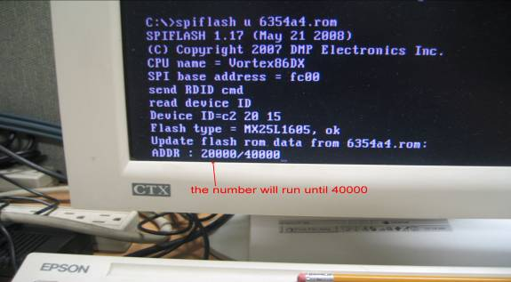

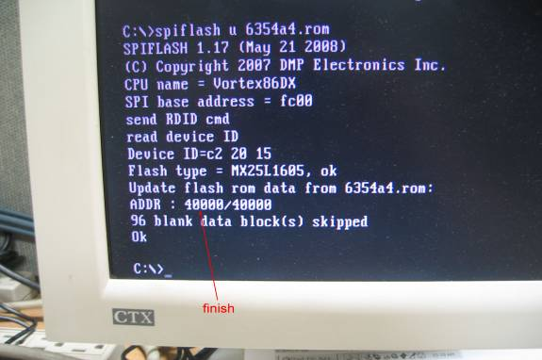

4. When finish the update. Reboot VDX-6327 board and into BIOS setting.

5. Select “Exit”, choose “Load Failsafe Defaults” press “OK”,
then choose “Load Optional Defaults” press “OK”.

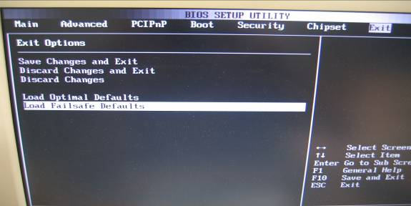

6. Press “F10” to save setting.

7. Done

8. Now you can get into the BIOS again to see if you can see what I show you on last email.

