Technical support notes No. 980519003

PCM-3115 Using ATA Devices Under DOS

The following procedure is for PCM-3115 to support ATA compatible devices such as PCMCIA Flash disk card or PCMCIA hard disk drive at DOS environment.

To Install The DOS Driver -- CardSoft3.1
To install CardSoft3.1, your hard disk must be installed with DOS. The system also requires a floppy drive.

Please modify your CONFIG.SYS file as follows:
DOS=HIGH
FILES=30
BUFFERS=30
DEVICE=C:\DOS\HIMEM.SYS
DEVICE=C:\DOS\EMM386.EXE RAM
DEVICE=C:\DOS\SETVER.EXE

When you install the PCM-3115 onto your system, be careful of the pin orientation. To install PCM-3115, some CPU cards/motherboards require either a special adapter or a reversed board insertion.

Remove the jumper at JP1 of the PCM-3115 completely to disable the boot ROM function.

Before turn on the power, you should check the jumper setting again. And make sure no PCMCIA device is inserted in the PCMCIA socket at this time.

First, boot from the hard disk. Then insert the diskette marked “CARDSOFT Installation Disk” in to the floppy disk. Then type the following command at “C>” prompt:
A:INSTALL

CardSoft will show you the version information on the screen. Then press any key to continue the installation.

The following message will be displayed:
Specify the number of PCMCIA adapters in the computer.
Select “1” adapter installed.
Specify the number of PCMCIA socket per adapter in the computer.
Select “2” socket per adapter.
Specify the directory name for installing the CardSoft files.
Press “Enter” to use the default directory.
Please confirm the destination drive and directory.
Press “Enter” to continue the installation.
You should see now the CardSoft creating sub-directory and copying the files to you hard disk. After CardSoft completes this step, it will ask you to “Update CONFIG.SYS” or “Create the SAMPLE CONFIG.SYS”
Select “Update CONFIG.SYS” and press “Enter” to continue.
The CardSoft will backup your original CONFIG.SYS file and display a message saying:
The original CONFIG.SYS file was copied to CONFIG.001
Press “Enter” to continue.
The CardSoft will update the CONFIG.SYS file at this point. If you use some memory manager program such as EMM386 or QEMM, you may see the following message:
The installation utility has detected the presence of the EMM386 memory manager. To insure proper functionality of the CardSoft driver, the parameter X=D000-DFFF must be added.
Select “Add Parameter” and press “Enter” to continue.
At this point, CardSoft will ask you to remove all PCMCIA cards from the system.
If any PCMCIA card was installed on your system, remove it now and press “Enter” to continue the installation.
You will be very happy to see it says “INSTALLATION COMPLETE”.
In order to activate the CardSoft software, the machine must be rebooted.
Please select the option “Reboot”.
CardSoft will ask you to remove the installation diskette.
Please remove the CardSoft driver diskette from floppy disk drive and press “Enter”.
Format ATA Devices
In order to read, write date or boot with ATA devices, you should initialize your ATA devices before using them. The following procedure will show you how to initialize your ATA devices:

Boot from the HDD; then insert the PCMCIA card into PCM-3115 socket-0 (lower socket). If PCM-3115 detects that PCMCIA device, you will hear the beep sound.
Type the following command at “C>” prompt:
CD C:\CARDSOFT
ATAINIT

ATAINIT is the program for you to initial your ATA devices and it will display the following message:
What drive letter do you want to init?
For normal operation the ATA device will become D-drive and you could press “D” to continue.
Program will display the Cylinders, Heads and Sectors information on the screen.
If the information is correct, press “Enter” to continue. Otherwise you will need to input the correct data manually.
Do you wish a compact format?
Press “N” to continue.
You will see the following message when the ATAINIT program finishes formatting:
Partition table successfully written
BPB Boot sector successfully wiped
Proceed with a DOS “FORMAT /U” command.

Type the following command to format your ATA device:
FORMAT D:/U
The following message will be displayed:
WARING: ALL DATA ON NON-REMOVABLE DISK
DRIVE D: WILL BE LOST!
Proceed with Format (Y/N)?
Press “Y” and “Enter” to continue.
Program will display the following message for you to enter the label for ATA drive:
Volume label (11 characters, ENTER for none)?
Please key in the label name then press “Enter” to finish the format.
If you don’t need to boot from your ATA device, you could bypass the next procedure and enjoy your new ATA drive now.

Make The ATA Device Bootable
In order to boot from your ATA device, you will need to transfer the system files from your hard disk to ATA device.
Type the following command to transfer the system files to your ATA device:
SYS D:

Shout down your system and change the jumper setting of JP1to enable the boot-ROM function. For example, you could short JP1’s pin 3-4 and 7-8 to assign the memory address D8000~DFFFF for boot-ROM.
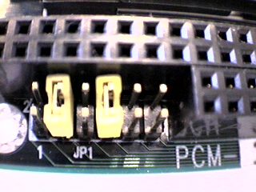
Turn on the power and go to CMOS setting manual:
If your ATA device is less than 15MB, it will become drive-A. And your original floppy disk drive will be re-mapped to drive-B. Please change your COMS setup to the following setting:
Drive C: Auto, MODE: Auto
Drive D: Auto, MODE: Auto
Drive A: 1.44MB
Boot Sequence: A,C
Swap Floppy Drive: Disabled
Boot Up Floppy Seek: Disabled
Before you exit the COMS setup manual, do not forget to save the changes.
Now, when you re-boot the system, you should see the system boot from the ATA drive as drive-A.

If your ATA device is larger than 15MB, it will become drive-C. And your original hard disk drive will be re-mapped to drive-B. Please change your COMS setup to the following setting:
Drive C: Auto, MODE: Auto
Drive D: Auto, MODE: Auto
Boot Sequence: C,A
Now, when you re-boot the system, you should see the system boot from the ATA drive as drive-C.

Note: This procedure has been tested by PCM-3115 with
Viper 170E, 170MB PCMCIA type-3 ATA hard disk FilmCard, 8MB PCMCIA type-2 ATA Flash card
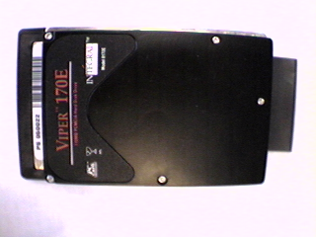
made by Integral Peripherals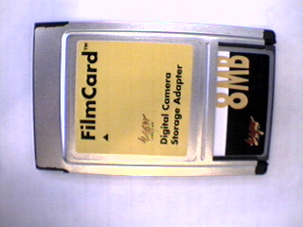 made by Eiger Labs, Inc.
AAEON Electronics, Inc.
AE Department
approve by: edited by:
Vincent Hsu Sheila Chang
http://www.aaeon.com
Tel:(732)203-9300 ext.123
Fax:(732)203-9311

